Intelligent Karaoke System

This system consist of a normal karaoke system and a recommendation system. The recommendation is a combination of collaborative methods and content-based methods.

Collaborative methods: Collaborative filtering methods are based on collecting and analyzing a large amount of information on users’ behaviors, activities or preferences and predicting what users will like based on their similarity to other users.

Content-based methods: Content-based filtering methods are based on a description of the item and a profile of the user’s preference. In a content-based recommender system, keywords are used to describe the items and a user profile is built to indicate the type of item this user likes.

And the karaoke system is simply use your iPhone as microphone to sing songs, also there are some control functions like pause, stop, start, etc. on the iPhone application.

transmissiontransmissiontransmissionThe following diagram shows the structure of the whole system.

User Preference

Social Networking

Search history

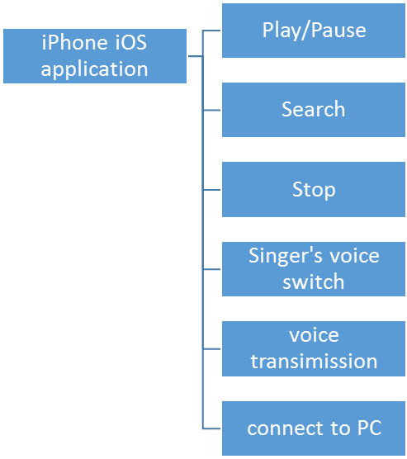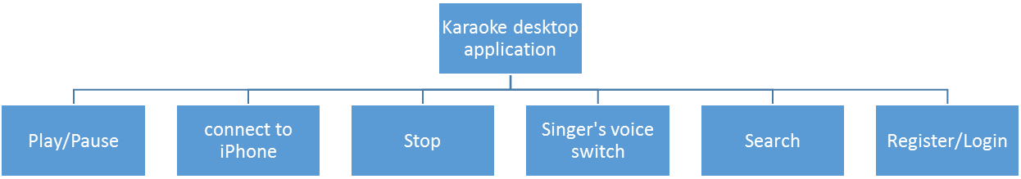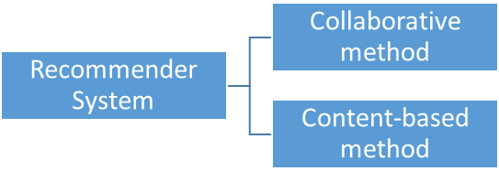

The recommender system will generate a list of song for each user based on user’s music preference which the user have to provide during the register process.

The user has to choose the preferable song’s categories, pop, jazz or something else and other information like preferable singers, preferable language, etc.

The user has to link his/her twitter account to his/her karaoke account during registration.

All songs will be stored on our server and maintained by administrator, the attributes of each song will be edited by administrator when he/she adds the song into database.